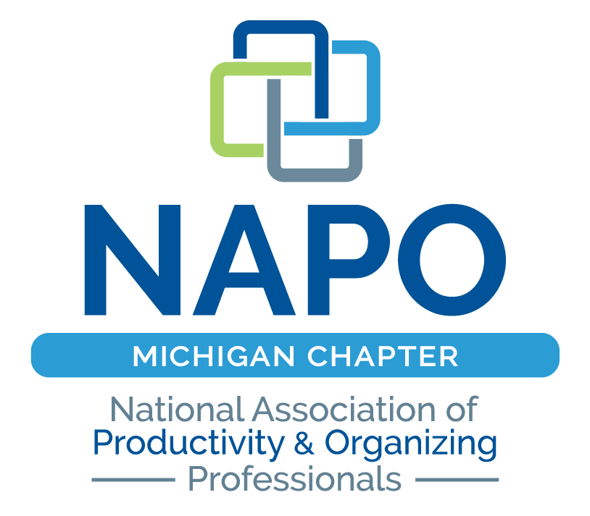

DETROIT’S

MESSIEST ROOM CONTEST

Sponsored by:
National Association of Productivity and Organizing Professionals – MI Chapter (NAPO-MI)
www.napomichigan.com
The Detroit News (News), www.detroitnews.com
Logical Placement, LLC, Betty Huotori, Team Leader, www.logicalplacement.com
As You Wish Organizing, LLC, Teri Closs, Team Member, www.asyouwish2organize.com
Balancing Your Space, LLC, Pam Hardy, Team Member, www.balancingyourspace.com
Erica Organizes, Erica Herker, Team Member, www.ericaorganizes.com
New Leaf Organizing, LLC, Cindy Greenleaf, Team member www.newleaforganizingllc.com
Re-Nest, LLC, Leigh MacCready, Team Member www.renestleigh.com

Contestant is applying for the opportunity to have a small team of NAPO-MI chapter professional organizers de-clutter and organize their messiest room during GO Month! in January 2018. Organizing products will be provided based upon sponsorship and need.

  - Contest Rules: Entry deadline Noon, November 15, 2018

- In-home room only (no garages, outbuildings or basements) up to 20 ft. x 20 ft. or 400 sq. ft.
- Room must be safe and dry (no infestations, water damage, excrement, mold, mildew or hoarded rooms will be considered).
- Offices with extensive paperwork needs will require additional consideration.
- Application must include:
  - 2-3 photos of your Messiest Room (no hi-resolution pictures, must be less than 1mb)
  - Backstory about your needs, how the space became messy and why you should be the winner (no more than 500 words)
  - Email competed application and pictures to betty@logicalplacement.com OR
  - Mail completed application and pictures to Betty Huotori, Logical Placement, LLC, 11469 Fawn Valley Trail, Fenton, MI 48430

  - Details: Contest runs from November 2 to Noon on November 15th.

- 3 finalists will be chosen at the sole discretion of the NAPO-MI Messiest Contest team and announced in mid November (no later than 11/17/2018). All entrants will be notified either way, by email or phone.
- Each finalist will have a 30-minute interview by one of the organizers. The winner will be announced by 12/7/2018.
- Organization work will be done mid to late January 2019. This is part of GO Month! Get Organized with a NAPO professional organizer or productivity specialist.
- Winner agrees to have sponsor banner(s) and NAPO signage displayed on property.
- Photographer will take before and after pictures of the Messiest Room to be used in News article(s), on NAPO-MI website and for any other publicity as determined by the Team.
- Winner will sign a formal contract for the work to be done.
- Completed application and pictures should be emailed to betty@logicalplacement.com or mailed to Betty Huotori, Logical Placement, LLC 11469 Fawn Valley Trail, Fenton, MI 48430.
- If you have any questions, please call Betty Huotori at (810) 348-1772.

  - Contestant Information:

Name: _________________________________________ Address: _____________________________________
City/State/Zip: _______________________________ Phone: _______________ Email: ______________

Backstory:
*Additional page may be attached (not to exceed 500 words total)

I am submitting this application to the Detroit Messiest Room Contest and have read and agree to the above Contest Rules and Details.

Signature: ____________________________________________ Date: _________________________
Printed Name:

Please indicate your preference:

☐ - I am available weekdays only
☐ - I am available on weekends only
☐ - I am available both weekdays and weekends

Please submit completed application along with (non hi-resolution) pictures to betty@logicalplacement.com
www.napomichigan.com

